 

INSTITUE FOR ADVANCE COMPUTING AND SOFTWARE DEVELOPMENT AKURDI, PUNE

Documentation on

“E-Bookstore”

E-DAC May 2021

Submitted by:

1041 Vedant Dalkari

1042 Darshan Rathore

Prashant Karhale Mr. Kashinath

Centre Coordinator Project Guide

Contents

Introduction 3

Documentation Purpose 3

Problem Statement 3

Product Scope 4

Aims and Objectives 5

Requirement Overview 6

1. Functional Overview 6

2. Non-Functional Overview 6

Use case Diagrams 7

Database Tables 13

User: - 13

book_ordersnew: - 13

book_dtls:-- 13

cart: - 14

Module Description 15

1. Register 15

2. Login 16

3. Home Page 17

4. Search Books 18

5. Order 19

6. Payment 20

7. Update 21

8. Admin Profile 22

Conclusion 25

Future Scope 25

# **Introduction**

The main objective of the document is to illustrate the Requirements of project E-Book Management system. The document gives the detailed description of both functional and non-functional requirements. It will also explain about the features of the system interface of the system. What the system will do, the constraint under which it must operate and how the system will react to external stimuli. The document is developed after a number of consultations with team members and specification of the given project.

The goal of this master's project is to design an online bookstore named **ebookstore.com**that mainly sells computer and technical books. The book inventories are stored in MySQL database. Customers can access the bookstore website. Customers will be able to search the database to find the books they want, check the availability, and place the order to buy the book using COD and Net Banking.

## **Documentation Purpose**

This document communicates the business requirements and scope for developing ebookstore.com. The scope of this document is to define the functional and non-functional requirements, business rules and other constraints requirements.

## **Problem Statement**

E-bookstore process is well organized online buying and selling of books. This system is well developed in various resources, for example Amazon site deals more about e-booking concept. This process has various issues in the basics of maintenance of database and updating in sites, so we have many issues in this process. The process of e-books is fully based on online, and the process for this mainly interaction between buyer and seller, buyer who enter the site for purchase of book will use search engine for book to purchase, the search engine will mainly focus on the database process, it used to search book for the buyer who mentioned the book name, author name, edition, publication details in the site, so that the search engine will show many books. There will be a payment option and option for pdf file or hardcopy delivery to home, the user should decide whether he want which one. Whether the choice hardcopy means, full detail address, driving license no, and then he should login with his username and password, and then payment through atm debit or credit card applicable.

## **Product Scope**

The software provides the visitor, customer and administrator an easy and efficient way to buy and manage books in online. Software provides following facilities to customer:

* Facilitates easy shopping online.
* Provides information about the products in categories.
* Provides e-mail facility for future correspondence
* Software provides the following facilities to the merchant.
* Manages the Transportation of hard copy of Book.
* Look after the payment method.

**DEFINITIONS, ACRONYMS AND THE ABBREVIATIONS :-**

**E-book manager :-**

* Refers to the super user who is the Central Authority who has been vested with the privilege to manage the entire system.

**User :-**

One who wishes to obtain the Books or Magazines.

**Visitor :-**

* One who visits to obtain Books or Magazines.

**Administrator :-**

* One who manages and maintain Books or Magazines

# **Aims and Objectives**

The main objective of the document is to illustrate the Requirements of project E-Book Management system. The document gives the detailed description of both functional and non-functional requirements. It will also explain about the features of the system interface of the system. What the system will do, the constraint under which it must operate and how the system will react to external stimuli. The document is developed after a number of consultations with team members and specification of the given project.

# **Requirement Overview**

## Functional Overview

* Register - Enter details in application form
* Login - Enter Username and Password.
* Search - Search book by attribute.
* Buy - Order for hard copy.
* Payment - Pay for books in different method.
* Update - Update User details

## Non-Functional Overview

* Bookmark - Bookmark the Website
* Categories - Book categories in Website.
* Most Popular - Highest purchased books.
* Recently Added – Most Recent Added books.
* Offers - Offer given by merchant.
* Carting - Mark and select multiple books.

# 

# Use case Diagrams

Fig 1: Admin Activity Diagram

Fig 2: User Activity Diagram

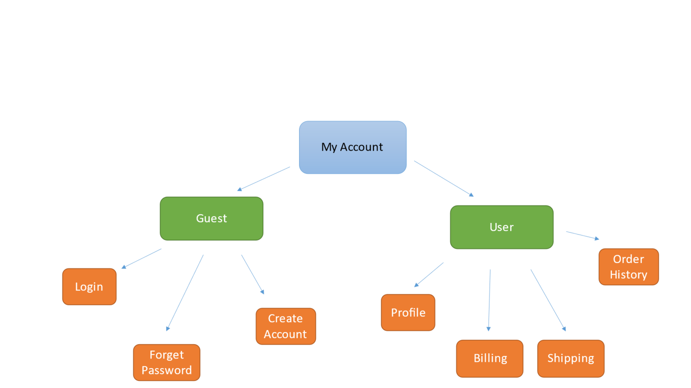

Fig 3: My Account Module

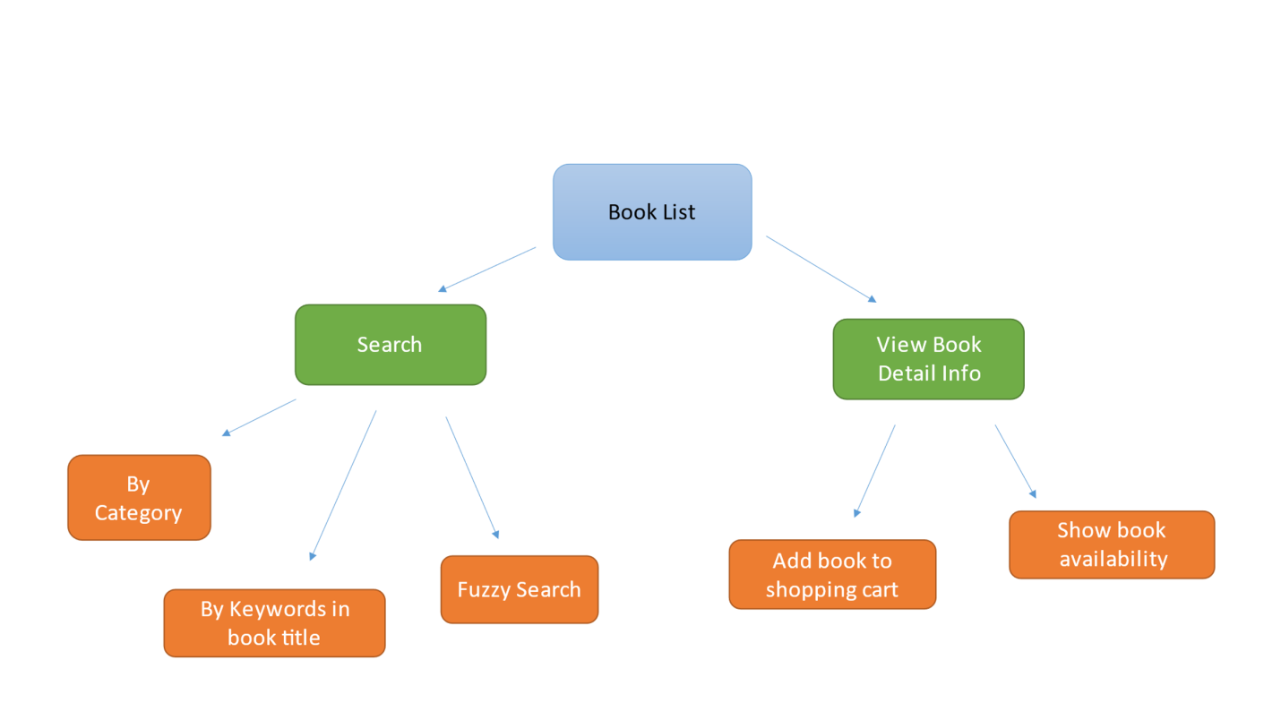

Fig 4: Browse Book

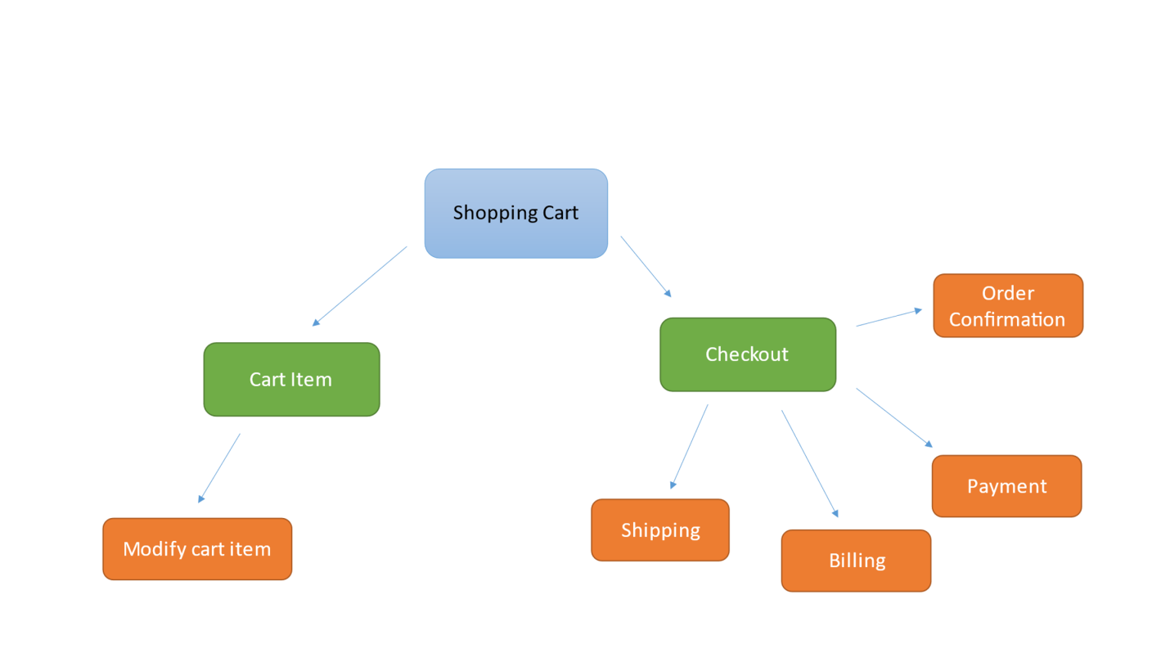

Fig 5: Shopping Cart

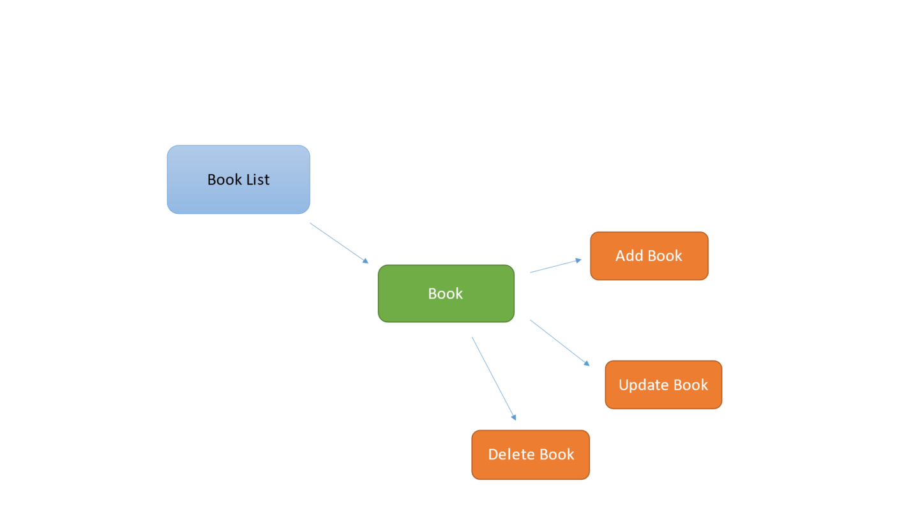

Fig 6: Book Management

Fig 7: Class Diagram

Fig 8: Use case Diagram

Fig 9: ER Diagram

# Database Tables

## User: -

|  |  |  |  |  |  |
| --- | --- | --- | --- | --- | --- |
| **Field** | **Type** | **Null** | **Key** | **Default** | **Extra** |
| id | int | No | PRI | NULL | auto_increment |
| name | varchar(45) | YES |  | NULL |  |
| email | varchar(45) | YES |  | NULL |  |
| phno | varchar(45) | YES |  | NULL |  |
| password | varchar(45) | YES |  | NULL |  |
| address | varchar(45) | YES |  | NULL |  |
| landmark | varchar(45) | YES |  | NULL |  |
| city | varchar(45) | YES |  | NULL |  |
| state | varchar(45) | YES |  | NULL |  |
| pincode | varchar(45) | YES |  | NULL |  |

## book_ordersnew: -

|  |  |  |  |  |  |
| --- | --- | --- | --- | --- | --- |
| **Field** | **Type** | **Null** | **Key** | **Default** | **Extra** |
| id | int | No | PRI | NULL | auto_increment |
| order_id | varchar(45) | YES |  | NULL |  |
| user_name | varchar(45) | YES |  | NULL |  |
| email | varchar(45) | YES |  | NULL |  |
| address | varchar(500) | YES |  | NULL |  |
| phno | varchar(45) | YES |  | NULL |  |
| book_name | varchar(45) | YES |  | NULL |  |
| author | varchar(45) | YES |  | NULL |  |
| price | varchar(45) | YES |  | NULL |  |
| payment | varchar(45) | YES |  | NULL |  |

## book_dtls:--

|  |  |  |  |  |  |
| --- | --- | --- | --- | --- | --- |
| **Field** | **Type** | **Null** | **Key** | **Default** | **Extra** |
| bookId | int | No | PRI | NULL | auto_increment |
| bookname | varchar(45) | YES |  | NULL |  |
| author | varchar(45) | YES |  | NULL |  |
| Price | varchar(45) | YES |  | NULL |  |
| bookCategory | varchar(500) | YES |  | NULL |  |
| status | varchar(45) | YES |  | NULL |  |
| photo | varchar(45) | YES |  | NULL |  |
| email | varchar(45) | YES |  | NULL |  |

## cart: -

|  |  |  |  |  |  |
| --- | --- | --- | --- | --- | --- |
| **Field** | **Type** | **Null** | **Key** | **Default** | **Extra** |
| cid | int | No | PRI | NULL | auto_increment |
| bid | int | YES |  | NULL |  |
| uid | int | YES |  | NULL |  |
| bookname | varchar(45) | YES |  | NULL |  |
| author | varchar(45) | YES |  | NULL |  |
| price | varchar(45) | YES |  | NULL |  |
| total_price | varchar(45) | YES |  | NULL |  |

# Module Description

In this project we have defined different modules to enable the E-Book Management in successful manner.

## Register

The register module contains the application form or registration form which contains following details. Name, Address, Contact number, E-mail id, Password etc.

Name, Address, Contact number, E-mail id, Password etc.

## Login

The Login module contain the form which contain membership name and member password. It includes Username and Password

## Home Page

The Home Page Module contains the navigation bar and important information of the website with books to browse.

## Search Books

The search book module contains list of books, from this list we search for the book which we need. This also contains another field called as categories where can select the category of the book.Graphical user interface, website

## Order

The Order Module contains the list of books in the cart with their Title, Author Name, Price, Quantity respectively.

## Payment

After the book is searched and found. Then the user is going to download the book. Before the downloading the books needs payment for that book. So, user has to select the type of transaction whether credit card (or) debit card (or) cash on delivery.Graphical user interface, website

## Update

The update module should be maintained by the website administrator. The admin should update each and every process like.

• Number of users registered

• Registered user viewing.

## Admin Profile

The Admin Module Consist of all the Backend functionalities required to provide stocks of the books with full control of the flow of the application related to sales and delivery system.

**OVERALL DESCRIPTION :-**

It will describe major role of the system components and inter-connections.

**PRODUCT PERSPECTIVE**

The ORS acts as an interface between the user and the 'e-book manager'. This system tries to make the interface as simple as possible and at the same time not risking the security of data stored in. This minimizes the time duration in which the user receives the books or magazines.

**SOFTWARE INTERFACE**

**Front End Client**

The User and Admin online interface is built using JSP and HTML. The Admin local interface is built using Java.

**Web Server**

Apache Tomcat application server (Oracle Corporation).

**Back End**

Mysql database

**HARDWARE INTERFACE**

The server is directly connected to the client systems. The client systems have access to the database in the server.

**SYSTEM FUNCTIONS**

Secure Registration of information by the Students.

Admin can generate reports from the information and is the only authorized personnel to add the eligible application information to the database.

# Conclusion

Thus, the project for E-BOOKSTORE has been successfully executed and codes are generated.

# Future Scope

The software provides both the customer and the merchant his PIN number which is unique. The software provides the following facilities to the customers:

* Facilitates easy shopping online anywhere with free shipping (conditions apply).
* Provides information about the products in categories.
* Can avail the facility of purchasing second hand products.
* Can reserve or order if the particular product is not available.
* Customers are provided with up-to-date information on the products available.
* Provides email facility for future correspondence.
* Provides backup facility.
* Can add nearly ten products to their shopping cart at a time

**TECHNOLOGIES TO BE USED :-**

* **HTML** - Markup Language used for creating web pages.
* **J2EE** - Java 2 Enterprise Edition is a programming platform and it is the part of the java platform for developing and running distributed java applications.
* **HTTP** -Hyper Text Transfer Protocol
* **TCP/IP** - Transmission Control Protocol/Internet Protocol is the communication protocol used to connect hosts on the Internet
* **BootStrap,Css,servlet and Jsp.**